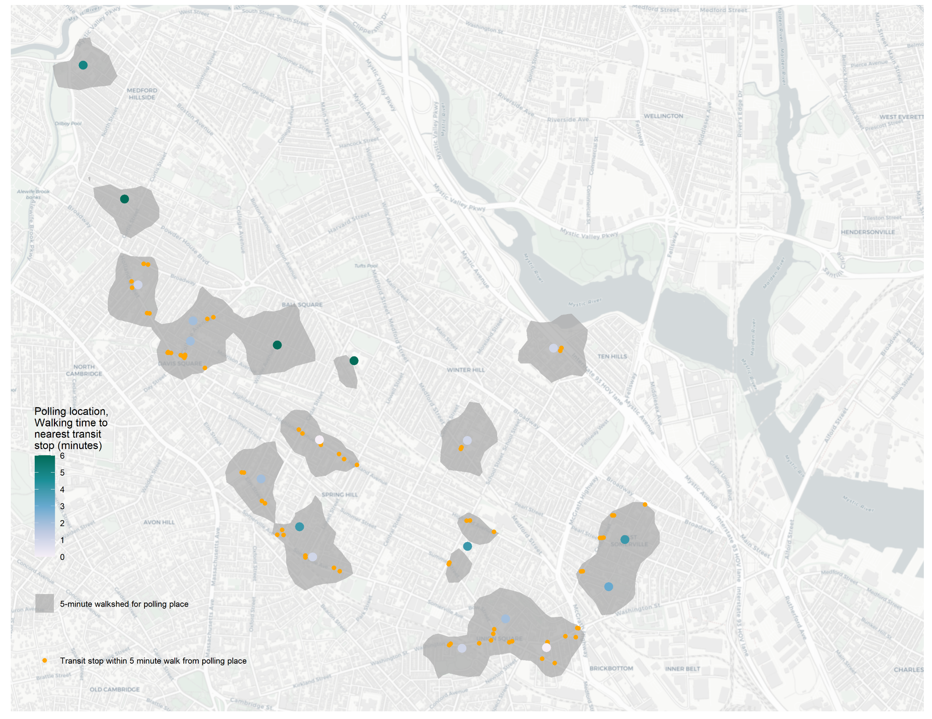

**Data sources:**

Base map: [OpenStreetMap](https://www.openstreetmap.org/copyright) contributors and [CARTO](https://carto.com/)

Transit stops: [MBTA GTFS](https://www.mbta.com/developers/gtfs)

Polling locations: [Somerville Open Data](https://data.somervillema.gov/browse?category=GIS+data)

**Acknowledgment:**

My classmate, Miles Voulgaris suggested I display only the transit stops within walksheds rather than the entire MBTA system. I think this simplifies the map considerably and clarifies the message.

Are polling places in Somerville easily accessible by walking and transit? This map illustrates the time to the nearest of transit stop for each of the nineteen polling places in Somerville. The area accessible to each polling place within five minutes is shaded gray, and the transit stops within those walksheds are shown in orange.

All polling places are within a six-minute walk of the closest transit stop and 15 out of 19 are within a five-minute walk. The average walking time from a polling place to the nearest transit stop is 2 minutes and 41 seconds.

Transit Access to Polling Places

Transit Access to Polling Places